**7.Demonstrate how to create a Collection.**

-Click on Collections, click on plus sign to create new collection:

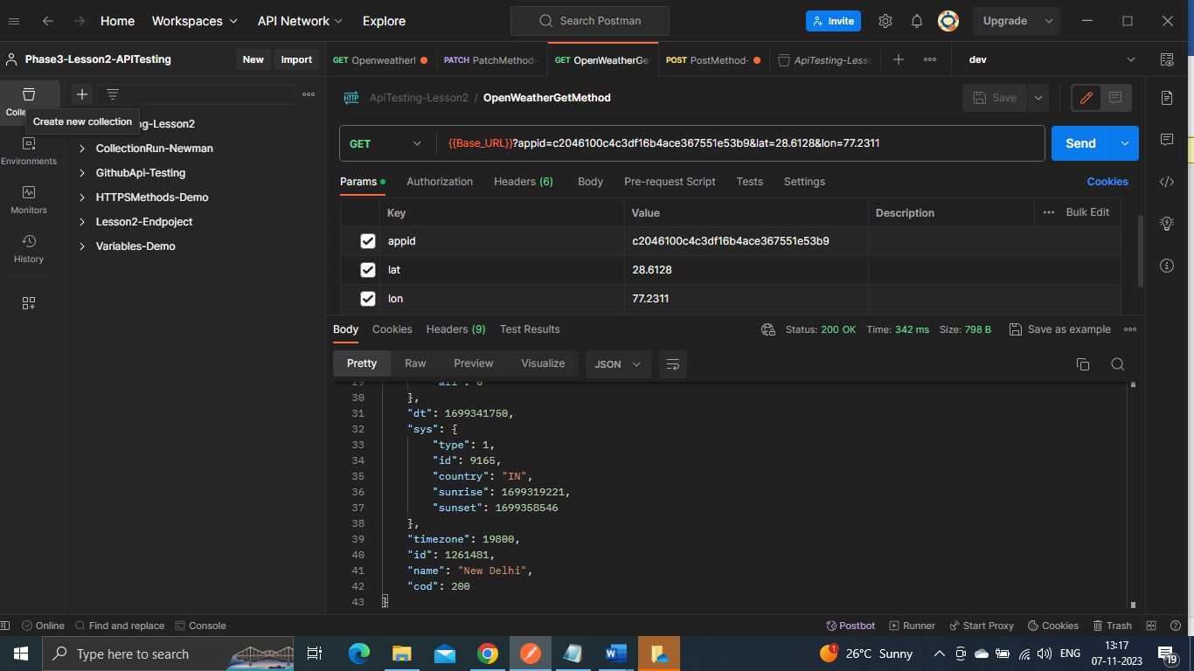-Click on Blank Collection: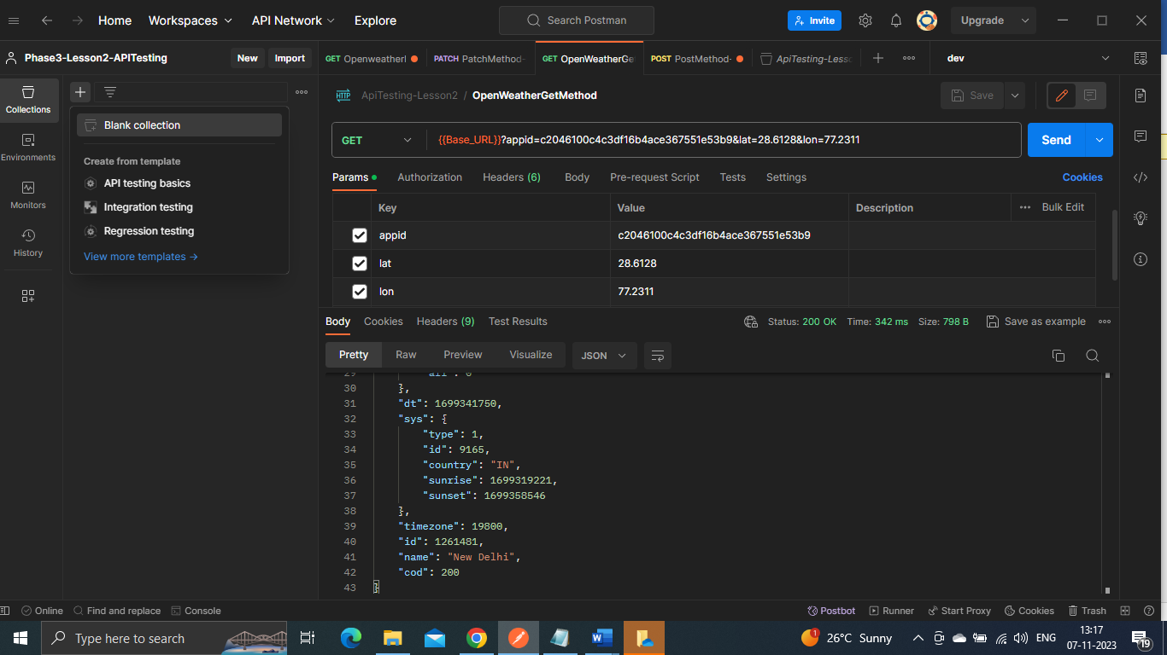-Name your collection: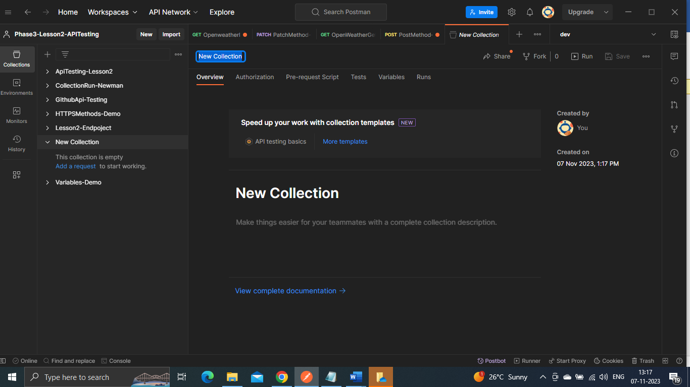-Collection has been created:

